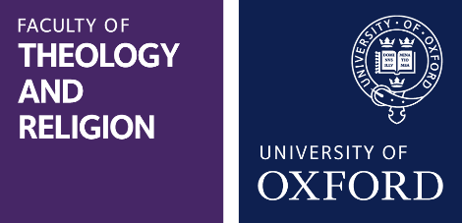
Leverhulme Early Career Fellowships 2026
Expression of Interest
Faculty of Theology and Religion

Please return to general.administrator@theology.ox.ac.uk by midday on Tuesday, 9 December, 2025.

Your proposed mentor must be a Faculty postholder and you must ask them to complete and return a Mentor Statement by the same date.

Name:
Current Institution:

Oxford Humanities Faculty / Institute:

Project Title:
Proposed Mentor:
Proposed start date for Fellowship

Has your doctoral thesis been submitted? (Yes / No)
Submission date (or expected submission date) of doctoral thesis:

Do you / will you hold a degree (any degree) from a UK higher education institution at the time of taking up the Fellowship (Yes / No)
OR
At the time of the application deadline will you hold an academic position in the UK (e.g. fixed-term lectureship, fellowship) which commenced no less than 4 months prior to the closing date?
If Yes, please provide details; otherwise put ‘not applicable’.

Have you held or do you currently hold postdoctoral positions to pursue your own independent research totalling 3 or more years: Yes / No.
Please describe below any current and previous postdoctoral positions and outline the nature of your role: briefly describe your research responsibilities and give an indication of the amount of time available to you to pursue your own independent research in each position. If you have not yet held a postdoctoral position you can enter ‘not applicable’.

Abstract: this account should be given in non-technical terms so as to be easily comprehensible to a non-expert (maximum 100 words).
Outline Budget – Give an indication of what additional research expenses you will be asking for. The Leverhulme Trust will fund up to £6k p.a.

Please return this form together with:
- Maximum 2-page Statement of Proposed Research (min Ariel 11pt, single spaced and 2cm margins): this should include aims, objectives, methodology and outcome (e.g. publication plans). The methodology should be clear and explicit, comprehensible to a non-expert. Include bibliographic references in full, including page numbers where relevant.
- Maximum 2-page CV, including education, thesis title and examiners, any awards, and publications.
- Mentor Support statement completed by your mentor, unless they are returning this separately.
Candidates should feel free to include a statement of any circumstances which have impacted on their research progress (for example, periods of illness, or maternity / paternity leave, etc).
Candidates should not expect any input from their proposed mentors into their Statement of Proposed Research at this stage.

